5 DOCKER

- DOCKER INTRODUCTION
Before docker installation and use
We need to understand application installment from old method to new and latest method

There are 4 types
- Static infra
- Bare Metal Infra
- Non Bare Metal Infra
- Docker

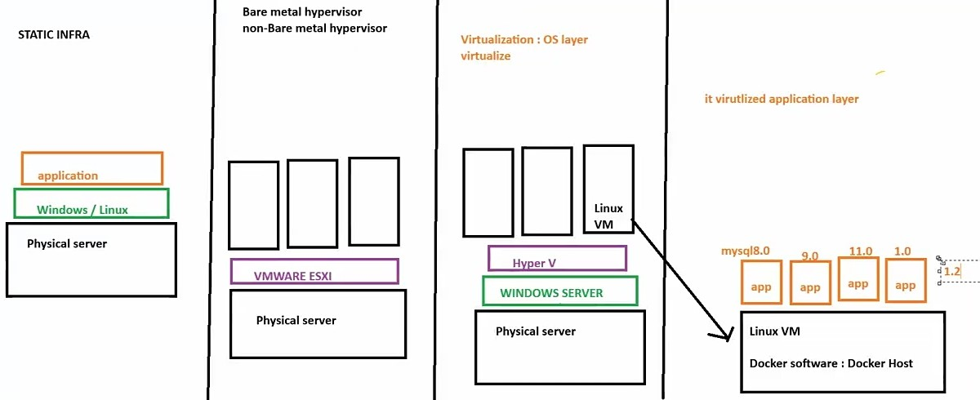

- Static Infrastructure:
- Cloud resources (servers, IPs, storage, network) are created manually
- They are fixed and do not change automatically
- Servers usually run continuously, even if load is low
Example: You create 3 virtual machines (VMs), You manually configure software on them, You always use those same VMs
- Even though it’s in the cloud, it behaves like traditional on-prem servers.

- How apps are installed:
- Applications are installed manually on the server.
Install OS → Install app → Configure → Run
- Changes require manual updates on the same server.
- Key point: App is tightly tied to the server. If the server fails, the app goes down.

- Static infrastructure is used when:
- Simplicity : Easy to understand, Good for beginners or small systems
- Predictable Workloads : Same traffic all the time, No sudden spikes
- Legacy Applications : Old apps that:
- Can’t auto-scale
- Require fixed IPs
- Need manual configuration
- Full Control : You know exactly which server does what, Easier troubleshooting in small setups

- Complications / Problems
- No Auto-Scaling : Traffic increases → server may crash,
  - Traffic decreases → you still pay for unused servers
- Manual Management : Updates, patches, and deployments are manual
  - Human errors are common
- High Cost : Servers run 24/7, You pay even when they are idle
- Poor Fault Tolerance : If one server fails → service may go down, Requires manual recovery
- Hard to Scale : Adding new servers takes time, Configuration must be repeated manually
- Inconsistent Environments : One server may differ from another
  - “It works on one server but not on another”

- Static vs Dynamic (Quick Comparison)
Feature | Static Infra | Dynamic Infra
Scaling | Manual | Automatic
Cost | Higher | Optimized
Flexibility | Low | High
Reliability | Lower | Higher
Maintenance | Manual | Automated

- Bare Metal Infrastructure:
- You get a physical server in a cloud provider’s data center
- No virtualization layer (no hypervisor, no VM)
- The hardware is dedicated only to you
- Simple words: It’s like renting an entire physical computer from the cloud.

- How apps are installed:
- Applications are installed directly on the physical server OS.
- No virtualization layer.
Physical server → OS → Application
- Best performance, but reinstalling or moving the app to another server is slow.

- Bare metal is used when you need:
- Maximum Performance : No VM overhead, Direct access to CPU, RAM, storage, network
- Low Latency : Faster response times, Critical for real-time systems
- Full Hardware Control : Custom OS, Custom kernel, Special drivers
- Compliance & Security : No sharing hardware with others, Required for strict regulations
- Specialized Workloads : Databases (SAP HANA, Oracle)
  - High-performance computing (HPC)
  - AI/ML workloads, Gaming engines

- Complications / Problems
- Expensive : Costs more than VMs, You pay for the full machine
- Slow Provisioning : Takes minutes to hours (sometimes days), Not instant like VMs
- Limited Scalability : Can’t scale quickly, Hardware availability is limited
- Manual Maintenance : OS updates, patches are your responsibility, More operational work
- Hardware Failure Risk : If the physical server fails:
  - App goes down, Recovery is slower than VM replacement
- Less Cloud-Native : Harder to integrate with Auto-scaling, Serverless,
  - Containers (without extra setup)

- Bare Metal vs Virtual Machines (Simple Table)
Feature | Bare Metal | VM
Hardware | Dedicated | Shared
Performance | Very High | Medium–High
Cost | High | Lower
Scaling | Slow | Fast
Maintenance | Manual | Easier
Use Case | Heavy workloads | General workloads

- Bare metal cloud infrastructure gives you full physical servers for maximum performance and control, but it is costly, slower to scale, and harder to manage.

- Non – Bare Metal Infrastructure:
- You run your application on virtual machines (VMs) or containers
- Hardware is shared with other users
- A hypervisor sits between hardware and your OS
- You rent a virtual computer, not the full physical machine.

- How apps are installed:
- Applications are installed inside virtual machines.
- Each VM has its own OS.
- Physical server → Hypervisor → VM → OS → Application
- Apps are easier to move, copy, or scale by cloning VMs.

- Non–Bare Metal Infrastructure Used : This is the most common cloud setup because it offers:
- Cost Efficiency : Pay only for the resources you use, No need to rent full physical servers
- Fast Provisioning : VMs start in seconds or minutes, Easy to create and delete servers
- Easy Scaling : Scale up/down automatically, Add or remove instances quickly
- High Availability : If one VM fails, another can replace it, Easy backup and recovery
- Cloud-Native Features Works well with: Auto-scaling, Load balancers, Containers,
  - Serverless services

- Complications / Problems
- Performance Overhead : Hypervisor adds a small performance loss,
  - Slower than bare metal for heavy workloads
- Shared Resources : Other users may affect performance, “Noisy neighbor” problem
- Less Hardware Control : No access to physical hardware, Limited customization
- Security Concerns (Perceived) : Hardware is shared (though providers secure it well)
  - Not ideal for very strict compliance needs
- Dependency on Provider : VM behavior depends on cloud platform, Limited low-level tuning

- Non–Bare Metal vs Bare Metal (Quick Comparison)
Feature | Non–Bare Metal | Bare Metal
Hardware | Shared | Dedicated
Cost | Low | High
Performance | High | Very High
Scalability | Easy | Hard
Provisioning | Fast | Slow
Use Case | Most apps | Heavy/critical apps

- Docker : Docker infrastructure in the cloud means
- Applications run inside containers
- Containers are created using Docker
- Containers share the same OS kernel
- They run on:
  - Virtual machines (non-bare metal) or
  - Bare metal servers

- How apps are installed:
- Applications are packaged into Docker images.
- No OS installation per app.
  - Host OS → Docker → Container (App + dependencies)
- App runs the same everywhere. Very fast to deploy and scale.

- Docker is used because it makes apps:
- Portable (Runs the same on) : Developer laptop, Test environment, Cloud production
  - “Works on my machine” problem is solved.
- Lightweight & Fast : Containers start in seconds, Use less memory than VMs
- Easy Scaling : Quickly start more containers, Perfect for microservices
- Consistent Environments : Same software versions everywhere, No configuration mismatch
- DevOps Friendly : Easy CI/CD integration, Faster deployments and rollbacks

- Complications / Problems
- Security Risks : Containers share the same OS kernel,
  - If one container is compromised, others may be affected
- Complex Management at Scale : Managing many containers is hard, Usually requires Kubernetes
- Persistent Data Handling : Containers are temporary,
  - Data must be stored outside (volumes, databases)
- Networking Complexity : Container networking is harder than VM networking,
  - Debugging can be tricky
- Learning Curve : Docker commands, images, registries, Kubernetes adds more complexity

- Docker Infra vs VM Infra (Simple Comparison)
Feature | Docker Containers | Virtual Machines
Size | Very small | Large
Start Time | Seconds | Minutes
OS | Shared kernel | Separate OS
Performance | Near native | Slight overhead
Isolation | Medium | Strong

- Simple Comparison Table (Application Installation)
Type | App Installation Method | Speed | Portability | Flexible | Fast to Scale
Static Infra | Manual install on server | Slow | ❌ Low | ❌ | ❌
Bare Metal | Direct install on physical OS | Slow | ❌ Low | ❌ | ❌
Non–Bare Metal (VM) | Install inside VM OS | Medium | ✅ Medium | ✅ | ✅
Docker | Run from image (container) | Fast | ✅✅ High | ✅✅ | ✅✅

Sir Explanation :
- Static infrastructure is a setup where servers are fixed and applications are manually installed and rarely changed.

- Bare Metal infrastructure is a physical server where applications run directly on the hardware without any virtualization.

Example : Monolithic application : Stand alone app
Web app and db are mixed in package and installed all at once
If any issue occurs and try to trouble shoot web it is hectic because depends on db and app also

- Non Bare Metal Infrastructure : can install multiple apps but with only one version
SOA – Service Oriented Architecture :
If there are n number of blocks or module 1 is cards
2 net banking
3 payment
If card block is having issue then card is trouble shooted but in card block with n number of sub blocks gets effected
But does have link with payment or net banking block

- Docker can install multiple apps with multiple versions
It supports multi platform and all versions
Micro services
It has separate for each services
And docker supports for micro services
As it has separate container

Docker Definition :
- Docker is a tool that lets you package an application and everything it needs (code, libraries, settings) into a container, so it runs the same everywhere.

- Docker is like a box that carries your app with all its requirements, so it works on any computer or cloud.

- Without Docker: “It works on my laptop but not on the server.”
- With Docker: “It works everywhere the same.”

- Key idea
- App + dependencies → Docker container
- Run container → app runs consistently

Docker = a way to run apps in lightweight containers instead of full virtual machines.
Docker is containerization tool
A containerization tool is software that packages an application with all its dependencies into a lightweight, portable container so it can run consistently anywhere.

It solves environmental related issues
It supports micro service application.
Images are stored in docker hub
Same kind of applications can be installed with multiple versions

Docker is free of cost depends on use ( if want premium it is paid )

- DOCKER ARCHITECTURE
- Docker works using Client–Server Architecture.
That means : One part gives commands, One part does the work

- 🧱 Main Components of Docker Architecture
There are 4 main components:
- Docker Client
- Docker Daemon
- Docker Images
- Docker Containers

      - Docker Client (The Commander) :
Technical word : CLI (Command Line Interface)
This is where you type commands : docker build, docker run, docker pull
Simple explanation : You are the boss.
You give instructions to Docker.
The client sends commands to the Docker Daemon.

      - Docker Daemon (The Worker Brain) :
Technical word : dockerd process
It runs in the background.
It : Builds images, Creates containers, Manages networks, Manages volumes
Simple explanation : This is the brain of Docker.
It listens to your commands and does the real work.
If daemon stops → Docker stops working.

      - Docker Images (Blueprint)
Technical word : Read-only layered template
An image contains : OS (Ubuntu, Alpine), Application, Libraries, Dependencies
Simple explanation : 📘 Image = Recipe book
You cannot run image directly.
You must create a container from it.
Example : docker pull ubuntu

      - Docker Container (Running App)
Technical word : Lightweight isolated runtime environment
Container is : Running instance of an image
- Has its own file system
- Has its own network
- Has its own process space
Simple explanation : 🏠 Container = House built from blueprint (image)
You can : Start, Stop, Delete,
Example : docker run -it ubuntu

- How They Work Together (Step-by-Step Flow)
- Step 1 : Docker Client receives command
- Step 2 : Client sends request to Docker Daemon
- Step 3 : Daemon checks : “Do I have nginx image?”
- If not → pulls from Docker Hub
- Step 4 : Creates container from image
- Step 5 : Container starts running

- What is Docker Hub?
Technical word : Public container registry
Docker Hub is : Online image storage
Like GitHub but for Docker images
Example : docker pull mysql

Advanced Technical View (Interview Level)
Docker internally uses:
containerd (container runtime)
runc (low-level container execution)
Namespaces (process isolation)
Cgroups (resource control)

Docker architecture follows a client-server model where Docker Client communicates with Docker Daemon to build images and run containers.

- DOCKER INTERNAL ARCHITECTURE
Docker is not magic.
It uses powerful Linux kernel features.

- Docker internally works using:
- Docker Client
- Docker Daemon (dockerd)
- containerd
- runc
- Namespaces
- Cgroups
- Union File System (Layered FS)

      - Docker Daemon (dockerd)
Technical meaning : Main background service that manages containers.
Simple explanation : It is the manager boss inside Docker.
It : Receives command from client
Talks to containerd
Builds images
Creates containers
Manages network & volumes
If dockerd stops → everything stops.

      - containerd (Container Runtime Manager)
Technical meaning : High-level container runtime
Simple explanation : This is the container supervisor.
It : Pulls images
Manages container lifecycle
Handles storage
Think : dockerd = company owner
containerd = project manager

      - runc (Low-Level Runtime)
Technical meaning : OCI-compliant runtime that actually creates containers
Simple explanation : This is the worker who actually builds the container.
It : Creates process
Applies namespaces
Applies cgroups
Starts the container
Think : runc = construction worker 🏗️

      - Namespaces (Isolation Technology)
Technical meaning : Kernel feature that isolates system resources
Types : PID namespace (process isolation)
NET namespace (network isolation)
MNT namespace (filesystem isolation)
UTS namespace (hostname isolation)
IPC namespace

      - Cgroups (Control Groups)
Technical meaning : Linux kernel feature for resource limiting
Controls : CPU, Memory, Disk I/O, Network

      - Union File System (Layered Storage)
Technical meaning : Layered, copy-on-write filesystem
Image Layers : Base OS layer, App layer, Library layer, Config layer

Simple explanation : Image = Stack of transparent sheets 📄
Container adds : One writable layer on top
This makes containers : Lightweight, Fast, Efficient

- Complete Internal Workflow
    - Client Sends Command
You type command.
Docker Client → sends request to → dockerd

    - dockerd Checks Image
If image not present
dockerd asks containerd
containerd pulls from Docker Hub

    - containerd Prepares Container
containerd : Prepares root filesystem, Creates container metadata

    - runc Creates Container
runc : Creates namespaces
Applies cgroups
Sets isolation
Starts process
Now container is running.

    - Kernel Does the Magic
Linux kernel : Handles isolation
Handles resource control
Manages processes

Docker internally uses containerd and runc to create containers using Linux namespaces for isolation and cgroups for resource control, all managed by dockerd.

- DOCKER INSTALLTION

- Install Docker on Linux (Docker Engine) Ubuntu / Debian

- Remove old versions (optional but recommended)
sudo apt remove docker docker-engine docker.io containerd runc

- Update system & install prerequisites
sudo apt update
sudo apt install -y ca-certificates curl gnupg

- Add Docker’s official GPG key
sudo install -m 0755 -d /etc/apt/keyrings
curl -fsSL https://download.docker.com/linux/ubuntu/gpg | \
sudo gpg --dearmor -o /etc/apt/keyrings/docker.gpg

- Add Docker repository
echo \
"deb [arch=$(dpkg --print-architecture) \
signed-by=/etc/apt/keyrings/docker.gpg] \
https://download.docker.com/linux/ubuntu \
$(lsb_release -cs) stable" | \
sudo tee /etc/apt/sources.list.d/docker.list > /dev/null

- Install Docker Engine
sudo apt update
sudo apt install -y docker-ce docker-ce-cli containerd.io docker-buildx-plugin docker-compose-plugin

- Verify installation
docker --version
sudo docker run hello-world

Run Docker without sudo (optional)
sudo usermod -aG docker $USER
newgrp docker

- 🪟 Install Docker on Windows (Docker Desktop)
Docker on Windows uses WSL 2 (recommended).

- System Requirements
- Windows 10/11 (64-bit)
- Virtualization enabled in BIOS
- WSL 2 supported

- Install WSL 2
Open PowerShell as Administrator:
wsl --install
Reboot when prompted.

- Download Docker Desktop
Go to Docker Official Site
Download Docker Desktop for Windows

- Install Docker Desktop
Run the installer
Enable Use WSL 2 instead of Hyper-V
Finish installation & reboot if needed

- Verify Docker
Open PowerShell / CMD / WSL terminal:
docker --version
docker run hello-world

- Quick Test (Both OS)
docker run -it ubuntu bash

- Common Issues
Problem | Fix
Docker command not found | Restart terminal / reboot
Permission denied | Add user to docker group
WSL not working | Enable virtualization in BIOS

- Install docker in Linux Virtual Machine
In Linux virtual machine to install docker

- 1st install updates using : apt update
- Now we use command : apt install docker.io -y

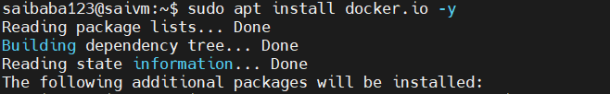

After installing Docker in linux
We call system known as docker host

- To check Version : docker --version

- IMAGE OPERATIONS
To download and run application or images we use docker hub
Hub.docker.com

1st you download images or apps from docker hub and then create container using it
Without download images from docker hub we can not create container

Once you create container you can not login directly
You need to use docket host ip address and port to login

- 1st install updates using : apt update
- Now we use command : apt install docker.io -y
- To check Version : docker --version

- Before downloading images check
- Now to check images present : docker images
It shows none as no image is downloaded

- To check container using images list : docker ps
It shows container name, image, when it is created and which port.
As of now no image is downloaded hence no container

- Download images ( OS or applications )
- To download image from docker hub : docker pull <image_name>
Ex : docker pull mysql

It downloads images from docker registry and install it
If you provide docker image name and version it will download that image version

- Download image with version : docker pull <image_name>:version
Ex : docker pull mysql:9

Else it will download latest one by default

- To search images in docker
- To search images in docker without using docker website : docker search <image_name>
Ex : docker search nginx
It shows all nginx images available in hub

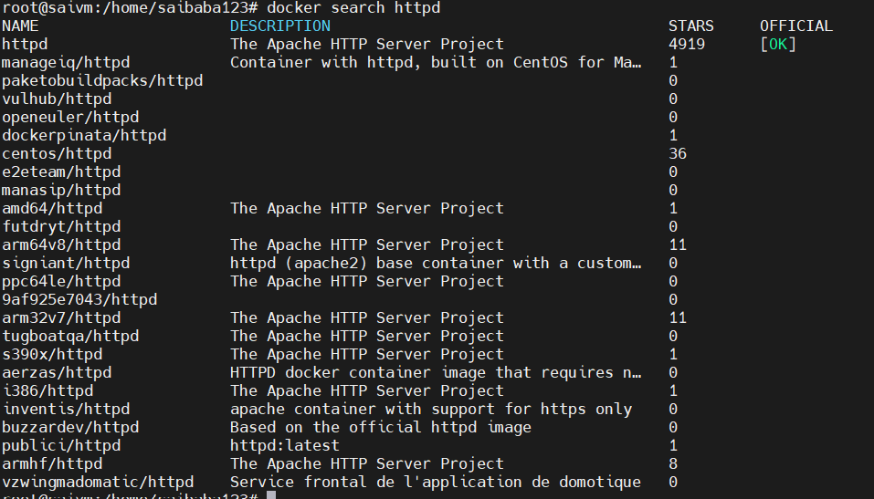

- After Downloading images
- Check images : docker images

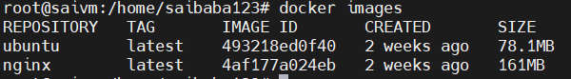

- Image inspect
- For checking or inspecting image : docker inspect image <image_name>
Ex : docker inspect image nginx

- Cmd : used by default which server to run In background
- Merged Dir, Upper Dir, Work Dir paths are mentioned at it is stored it that location
- Layers : it shows layers as updates

- To check whether images are good or corrupted
- To check use command : docker images -f dangling=true
- docker → Docker command-line tool
- images → List Docker images
- -f → Filter
- dangling=true → Show images that are dangling (untagged and unused)

- A dangling image is an image that:
- Has no name and no tag
- Is not referenced by any container
- Usually appears as <none>:<none> in the image list

- These images are typically created when:
- You rebuild an image (docker build) and the old version is no longer tagged
- An image build fails partway
- Tags are moved to newer images

- To delete dangling images : docker image prune
- Type y

- Delete images which are not used by any container
- To delete images not linked to any container : docker image prune -a
- docker → Docker command-line tool
- image → Docker images
- prune → Remove / clean up unused data
- -a → All (remove all unused images, not just dangling ones)

- “Remove all unused Docker images, including both dangling and unreferenced images.”
- Or Deletes all unused Docker images.

- Create container using pulled images
- To create : docker run -d --name sai -p 8080:80 nginx
- docker run → Create & start a container
- -d → Detached (background) mode
- --name web01 → Container name
- -p 8080:80 → Port mapping (host → container)
- nginx → Image used

Ex : docker run -d –name web01 -p8080:80 nginx
docker run -d –name web02 -p8081:80 httpd
docker run -d –name web01 -p8080:80 nginx

Run an Nginx container named web01 in detached mode and map port 8080 on the host to port 80 in the container.
Or Starts an Nginx container in background with port mapping.

- To stop container
- To stop container using name : docker stop web01
- docker → Docker command-line tool
- stop → Stop a running container
- web01 → Container name

Stop the running Docker container named web01.
Or Stops container web01.

- To remove container
- To remove created container using container name : docker rm web01

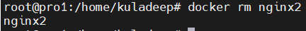

- To remove or delete image
- To remove : docker rmi <image_name>
Ex : docker rmi httpd

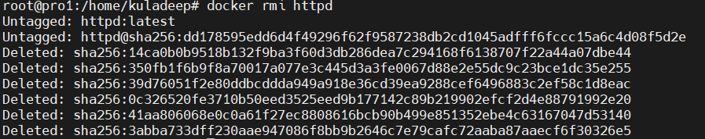

- To check list of containers
- To check containers running : docker ps
- Shows only running containers

- To check container running and created but not running : docker ps -a
- Shows all the containers which are running and stopped

- To create and start container
- To create container : docker create <image_name>
Container is created using random name

- To create container with custom name : docker create --name nginx01 nginx

- To start container : docker start <conid/con_name>
- To stop container : docker stop <conid/con_name>

- To list out containers : docker ps -a
- To remove container : docker rm <conid/con_name>

- Image in background or foreground mode
- When you download or pull image
- Cmd it is bin/bash
It works on background process and not interactive mode

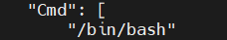

- Cmd it is foreground like Nginx, httpd
It will work on foreground process is like interaction mode



- Image in foreground will start when you execute start operation

- Image which are in background process
- Cmd it is bin/bash
It works on background process and not interactive mode

- When you try to run : docker create –name name01 ubuntu
as ubuntu is os server
- Using this command os will not come up or to interactive mode
- Hence start stop rm will not work

- Create a container which is background process to fore ground process
- To create a container in interactive mode : docker create –name srv01 -it ubuntu
used to create a container from image which is used to run in background process to foreground process
It = interactive terminal
- Now you can start stop rm etc using it in command

- For logging in to container ( OS )
- We can not directly connect to container
- 1st we need to login to docker host as
once docker is installed in linux it becomes docker host
- There are 2 methods to login
      - Using attach method
docker attach <containername>
  - By default it is in root user
  - To exit use : exit
  - Using attach mode once container is created and login we will be in container
  - But when we exit by default container will be in stop mode but not in running

- Docker run command is combination of pull, create, start, attach, stop

- Using run command
docker run --name web01 httpd
- It is combination of pull create start

- Use command : docker run -d --name web02 httpd
This command run container in detach mode hence when you exit it will be still in running mode even you exit also.

-d for detach mode
-it for interactive mode for login

- For exiting without stopping container
- Ctrl + p and ctrl +q
- Use both one after another

- CONTAINER OPERATIONS

- Docker container operations are commands used to create, start, stop, inspect, monitor, and delete containers.
- Image → Create → Start → Run → Stop → Restart → Delete

- Common Docker Container Operations (with commands)
- Create / Run a Container : Creates and starts a container.
docker run nginx ( for background process )
docker run -dit --name web nginx ( for foreground process )

- List Containers
docker ps # running containers
docker ps -a # all containers

- Start a Container
docker start web

- Stop a Container : Gracefully stops a running container.
docker stop web

- Restart a Container
docker restart web

- Pause / Unpause Container : Temporarily freezes container processes.
docker pause web
docker unpause web

- Execute Command Inside Container : Run a command inside a running container.
Very common in troubleshooting.
docker exec -it web /bin/bash

- View Container Logs
docker logs web
docker logs -f web # live logs

- Inspect Container (Details) : Shows configuration, IP, mounts, env variables.
docker inspect web

- Monitor Container Resource Usage :
docker stats
Shows : CPU, Memory, Network I/O, Disk I/O

- Copy Files To/From Container
docker cp file.txt web:/app/
docker cp web:/app/log.txt .

- Rename Container
docker rename oldname newname

- Remove Container : docker rm web
Force remove : docker rm -f web

Summary Table (Quick Revision)
Operation | Command
Run | docker run
List | docker ps
Start | docker start
Stop | docker stop
Restart | docker restart
Exec | docker exec
Logs | docker logs
Inspect | docker inspect
Monitor | docker stats
Remove | docker rm

- Docker container operations are commands used to manage the lifecycle, execution, monitoring, and cleanup of containers.

Docker run [ pull, create, start, attach, stop ]

- What is docker socket
- The Docker socket (usually called /var/run/docker.sock) is the communication endpoint that lets clients talk to the Docker daemon.
  - 🐳 Docker daemon = the engine
  - 🔌 Docker socket = the control cable

- What docker socket exact :-
  - A Unix domain socket file
  - Created by the Docker daemon when it runs
  - Default path : /var/run/docker.sock
- Any tool that can access this socket can send Docker API commands.

- What uses the Docker socket : docker CLI (docker ps, docker run, etc.)
- Docker Compose
- Kubernetes components (in some setups)
- CI/CD tools (Jenkins, GitHub Actions runners, etc.)
- Custom scripts using the Docker API

- When you run : docker ps
- The CLI talks to the daemon through the Docker socket.

- Why it matters (⚠️ security!)
Access to the Docker socket is basically root access to the host.
If someone can access docker.sock, they can:
- Start containers
- Mount host filesystems
- Run privileged containers
- Escape containers and control the host

- Super user permission
- For providing super user permission to docker socket : sudo chmod 666 /var/run/docker.sock
- sudo → Super User DO
- chmod → CHange MODe
- 666 → Permission value (read + write for everyone)
- /var → VARiable data directory
- /run → Runtime system information
- docker.sock → Docker socket file

- Gives everyone permission to read and write to the Docker socket
- So any user or process on the system can communicate with the Docker daemon.

- What does 666 mean exactly?
- Number Permission
- 6 Read (4) + Write (2)
- 6 Read (4) + Write (2)
- 6 Read (4) + Write (2)

- Applied to:
- Owner → Read + Write
- Group → Read + Write
- Others → Read + Write
- 🚫 No execute permission

- Using this command :
  - Fixes: permission denied while trying to connect to Docker daemon

- Important warning : Running this is very insecure
  - Anyone can control Docker → anyone can control the host system.
Safer alternative (recommended)
bash
Copy code
sudo usermod -aG docker <username>
Then log out and log back in.

- This command makes the Docker socket writable by everyone, effectively giving all users Docker (and near-root) access.

- Docker commands
- To get every update or function or event going on in docker : docker events
- To run httpd container : docker run httpd
if httpd is in local or downloaded it just create container and runs else
pull, create, run and stop
- To run container in detach mode : docker run -d httpd
for running in detach mode as when you login and logout it wont stop
unless you manually stop it
- To run ubuntu in interactive mode : docker run -d -it –name srv01 ubuntu
as ubuntu runs in background process
- To login into ubuntu container : docker attach <container_name>
when you login to container and logout
container stop and delete it or kill it

- For logging into container and without delete it : docker exec -it <container_name> /bin/bash

docker exec -it <container_name> /bin/bash
- docker → Docker CLI (no full form; named after shipping containers 🐳)
- exec → Execute command
- -i → Interactive mode
- -t → Allocate a TTY (terminal)
- <container_name> → Name or ID of the running container
- /bin → BINaries directory
- bash → Bourne Again SHell

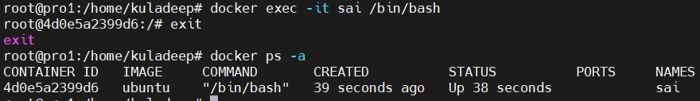

  - This command makes the Docker socket writable by everyone, effectively giving all users Docker (and near-root) access.
  - Opens an interactive Bash shell inside a running Docker container

  - So you can: Run Linux commands inside the container, Debug issues
    - Check files, logs, processes, etc.

- Why -it is used together
  - -i keeps STDIN open
  - -t gives you a terminal interface
  - Without -it, the shell would exit immediately.

  - If /bin/bash is not available
    - (Some lightweight images like Alpine)
    - docker exec -it <container_name> /bin/sh
This command lets you log into a running Docker container using an interactive Bash terminal.

- Now /bin/bash with this path both child and parent paths are created
- And when you logout child path is deleted but parent path will be on and container wont get deleted

- For controlled exit : docker attach –detach-keys=”ctrl-z” <container_name>
when you login to container and logout but container won’t delete

- For exiting container other naming instead of exit
- Use command : docker attach --detach-keys="ctrl-z" <container_name>
- docker → Docker CLI (no full form; named after shipping containers 🐳)
- attach → Attach your terminal to a running container
- --detach-keys → Custom detachment key sequence
- ctrl → Control key
- z → Keyboard key Z
- <container_name> → Name or ID of the running container

- Attaches your terminal to a running container and sets Ctrl + Z as the key combination to safely detach from it

- So you can:
- View container output (STDOUT / STDERR)
- Interact with the container if it’s running in interactive mode
- Detach without stopping the container

- Why --detach-keys is useful : Default detach keys are Ctrl + P, Ctrl + Q
  - Hard to remember or conflict with terminal shortcuts
  - This option lets you choose your own key combo

- What happens when you press Ctrl + Z
- You detach from the container
- The container keeps running
- You return to your host terminal

- Important note ⚠️
- If the container’s main process reads Ctrl + Z, behavior may differ
- Attaching to non-interactive containers is read-only

- This command connects your terminal to a running container and lets you detach using Ctrl + Z without stopping it.

- Network commands
- List of docker networks : docker network ls
- docker → Docker CLI (no full form; named after shipping containers 🐳)
- network → Docker network management command
- ls → LiSt

- Lists all Docker networks available on the system
- It shows: Network names
- Network IDs
- Network drivers (bridge, host, overlay, none, etc.)
- Network scope (local / swarm)

- Typical output fields
- Column Meaning
- NETWORK ID Unique identifier of the network
- NAME Network name
- DRIVER Network type
- SCOPE Where the network applies

- Why this command is used
- Check existing Docker networks
- Debug container connectivity issues
- Verify custom or default networks
- Network management in Docker Swarm

- Default networks you’ll see
- bridge → Default container network
- host → Uses host network directly
- none → No networking
- ingress → Swarm routing network

- This command displays all Docker networks configured on the Docker host.

- When you create a container it would use default bridge network

- Inspect network
- Use command : docker inspect bridge
- docker → Docker CLI (no full form; named after shipping containers 🐳)
- inspect → Inspect / examine detailed information
- bridge → Name of the default Docker bridge network

- Displays detailed configuration and runtime information about the Docker bridge network

- It returns data in JSON format showing: Network ID
- Subnet and gateway
- Connected containers
- IP address allocations
- Driver options
- Network scope

- What is bridge here ?
- bridge is Docker’s default network
- Used when no network is specified during docker run
- Provides NAT Network Address Translation-based container networking

- Why this command is used
- Troubleshoot container networking
- Check subnet or gateway IP
- See which containers are attached
- Understand Docker’s network setup

- Example info you might see
- "Subnet": "172.17.0.0/16"
- "Gateway": "172.17.0.1"
- "Containers": { ... }

- This command shows complete technical details of the default Docker bridge network.
- In inspect it shows default subnet range, when any container is created, it just creates under subnets range it self

- Run Ubuntu container in detached mode with an interactive terminal with naming
- Use command : docker run -dit --name <container_name> ubuntu
- docker → Docker CLI (no full form; named after shipping containers 🐳)
- run → Create and start a new container
- -d → Detached mode (runs in background)
- -i → Interactive mode (keeps STDIN open)
- -t → Allocate a TTY (terminal)
- --name → Assign a name to the container
- <container_name> → User-defined container name
- ubuntu → Ubuntu Linux base image

- Creates and starts an Ubuntu container in detached mode with an interactive terminal and assigns it a custom name

- What happens : Ubuntu image is pulled (if not already available)
- Container starts in the background
- STDIN stays open, allowing later interaction

- You can connect using : docker exec -it <container_name> /bin/bash
- Why -dit together : -d → run in background
  - -i + -t → allow interactive access later

- This command runs an Ubuntu container in detached interactive mode and names it as specified.

- After creating container how to login to container
- Use command : docker -exec -it <container_name> /bin/bash
- docker → Docker CLI (no full form; named after shipping containers 🐳)
- exec → Execute a command inside a running container
- -i → Interactive mode (keeps STDIN open)
- -t → Allocate a TTY (terminal)
- <container_name> → Name or ID of the running container
- /bin → BINaries directory
- bash → Bourne Again SHell

- Opens an interactive Bash shell inside a running Docker container
- You can : Run Linux commands inside the container
  - Debug and troubleshoot, Inspect files and processes

- Containers are light weight and hence every thing installed on own and depends on requirement
- When you install os in a container due to light weight, no apps or libraries will install
- We need to install on our own according to requirement

- Installing ping function
- Use command : apt install iputils-ping -y
if normal user add sudo to it
- apt → Advanced Package Tool
- install → Install a software package
- ip → Internet Protocol
- utils → Utilities (helper tools)
- ping → Packet Internet Groper (commonly taught full form)
- -y → Yes (automatically answer “yes” to prompts)

- Installs the ping network diagnostic utility and automatically confirms the installation
- After running it, you can use: ping google.com
  - to check network connectivity.

- What is iputils-ping : Package that provides the ping command
- Used to test whether a host is reachable over a network
- Often missing in minimal Linux or Docker images

- Why -y is used : Skips interactive confirmation
  - Useful in scripts, Dockerfiles, and automation

- Common use case : Debugging network issues
- Testing container or server connectivity
- Lab and exam environments

- This command installs the ping networking tool using APT and auto-confirms the installation.

- Name to name it will not ping
- It will ping only ip address
- Name to name ping can not done in bridge network

- Create docker network bridge
- Use command : docker network create <bridgename>
For creating a new bridge network

- Create container under new bridge network
- Use command : docker run -dit –name srv03 –network=mybridge ubuntu
- docker → Docker CLI (no full form; named after shipping containers 🐳)
- run → Create and start a new container
- -d → Detached mode (runs in background)
- -i → Interactive mode (keeps STDIN open)
- -t → Allocate a TTY (terminal)
- --name → Assign a name to the container
- srv03 → User-defined container name
- --network → Specify Docker network
- mybridge → User-created bridge network name
- ubuntu -> using ubuntu os server

- Creates and starts a container named srv03, runs it in the background with a pseudo-terminal, and connects it to the mybridge network

- Why -dit together : -d → run in background
  - -i + -t → allow interactive terminal access later (e.g., docker attach, docker exec)

- Why --network=mybridge : Places the container on a custom bridge network
  - Enables container-to-container communication by name
  - Better isolation than the default bridge

- Important note ⚠️: This command is usually followed by an image name
  - docker run -dit --name srv03 --network=mybridge ubuntu
  - Without an image, Docker will throw an error

- This command runs a Docker container in detached interactive mode, names it srv03, and attaches it to a custom bridge network.

- In default bridge network communication happens only using ip hence ping happens only using ip
- In create bridge network communication happens using ip and name hence ping happens using ip and name

- Create container naming port
- Use command : docker run -d –name nginx01 -p8080:80 nginx
- docker → Docker CLI (no full form; named after shipping containers 🐳)
- run → Create and start a new container
- -d → Detached mode (runs in background)
- --name → Assign a name to the container
- nginx01 → User-defined container name
- -p → Port mapping / publishing
- 8080 → Host machine port
- 80 → Container port (HTTP default)
- nginx → NGINX web server image

- Runs an NGINX web server container in the background, names it nginx01, and maps host port 8080 to container port 80
  - So you can access NGINX using : http://localhost:8080

- Why port mapping is used : Exposes container services to the host
  - Allows browser access to containerized apps
  - Avoids port conflicts on host

- What happens internally :
  - Requests to host:8080 → forwarded to container:80
  - NGINX listens on port 80 inside the container

- This command starts an NGINX container in detached mode and exposes it on port 8080 of the host.

- Network in Docker
- A Docker network is a virtual communication layer that allows containers to communicate with Other containers, The Docker host, External networks (internet)
- Docker network also allow how containers talk to each other and the outside world
- Docker networking handles:
- IP address assignment
- DNS-based container name resolution
- Routing and isolation
- Port forwarding

- Types of Networks in Docker
- Bridge Network (Default)
- Meaning : Containers are connected through a virtual bridge
  - Each container gets a private IP
- Used for : Applications running on the same host
  - Web app + database communication

- Host Network : High performance, low isolation
- Meaning : Container shares the host’s network directly
  - No port mapping needed
- Used for : Network-intensive apps
  - Monitoring and system tools

- Host network is a Docker networking mode where a container shares the host machine’s network stack directly.
- Container uses the same IP address and ports as the host
- No virtual bridge, no NAT, no port mapping.
- Host network mode lets a Docker container share the host’s network directly for maximum performance but minimal isolation.
- Only one container can run at a time due to no isolation and direct access
- No ip address range but bridge network has ip range

- How host network works
  - Normally (bridge network): Browser → Host Port → Docker Bridge → Container Port
  - With host network: Browser → Host Network → Container

- The container:
- Uses the host’s IP
- Listens directly on host ports
- Bypasses Docker’s bridge and NAT

- How to use host network
  - docker run --network host nginx or
  - docker run --net=host nginx

- Why host network is used
      - Better performance : No NAT or port forwarding, Lower network latency, Higher throughput
  - Used in : High-performance applications, Network monitoring tools
- No port mapping needed : You don’t need -p 8080:80
  - Container binds directly to host ports
  - Example: docker run --network host nginx
    - NGINX listens on port 80 of the host

- Access host-only services : Containers can easily talk to: localhost services
  - System daemons, Hardware-bound services

- Required by some apps
  - Used by: DNS servers, Load balancers, VPNs, Monitoring tools (Prometheus exporters, sniffers)

- Limitations & risks ⚠️
      - Security risk : Container has full access to host network, Less isolation
      - Port conflicts : Two containers can’t use the same port, Same as running apps directly on host
      - Not portable : Behaves differently across environments
  - Limited support on Docker Desktop (Mac/Windows)

Host vs Bridge (quick comparison)
Feature | Bridge | Host
Network isolation | Yes | No
Port mapping needed | Yes | No
Performance | Normal | High
Security | Safer | Riskier

- None Network : Maximum isolation
- Meaning : Container has no external network access
- Used for Security-sensitive workloads
  - Offline processing

- Overlay Network : Multi-host communication
- Meaning : Allows containers on different Docker hosts to communicate
- An overlay network is a virtual network that connects Docker containers running on different Docker hosts (machines) as if they are on the same local network.
- It works on top of the host networks (that’s why it’s called overlay).
- Overlay networks are mainly used with Docker Swarm (multi-host Docker setup).
  - Requires Docker Swarm
- Used for : Microservices, Distributed applications

- Why is it used : Overlay networks are used when you need containers on different servers to talk to each other securely and easily.
  - Key reasons:
      - Multi-host container communication : Containers running on different Docker hosts can communicate
  - No need to manually configure routing or firewall rules
Example:
  - Web container (Host A) ---> API container (Host B)
  - They communicate as if they are on the same LAN.

    - Used in Docker Swarm : Overlay is the default and recommended network type for Docker Swarm services
  - Services automatically get DNS-based service discovery
Example: docker service create --name web --network my_overlay nginx

- Built-in service discovery (DNS) : Containers can reach each other by service name
  - No need to know IP addresses
Example: curl http://backend:8080

- Secure communication : Supports encryption (VXLAN + IPsec)
  - Traffic between hosts can be encrypted

- Scalability : Easy to scale services across many nodes
  - New containers automatically join the network

- How Overlay Network Works :
- Uses VXLAN (Virtual Extensible LAN)
- Each container gets a virtual IP
- Docker manages:
  - Routing, Encapsulation, Encryption
  - You don’t have to configure this manually 🚀

- When should you use Overlay Network?
- Use overlay network when:
  - You have multiple Docker hosts
  - You are using Docker Swarm
  - You need container-to-container communication across hosts
- Don’t use overlay network when:
  - You are running containers on a single host, Bridge network is enough

- Macvlan Network : Containers behave like physical machines
- MAC – Media Access Control Virtual LAN
- A Docker network driver that assigns each container its own MAC address, making the container appear like a physical device on the network.
- Meaning : Container gets its own MAC and IP address
  - Appears as a device on the local network
- Used for Legacy applications
  - Network appliances

- IPvlan Network : Lightweight version of Macvlan
- IP – Internet Protocol Virtual LAN
- A Docker network driver where containers get unique IP addresses but share the same MAC address as the host, resulting in better performance and scalability.
- Meaning : Containers share a MAC address but have different Ips
- Used for Large-scale container deployments

- Quick comparison table
Network Type | Isolation | Multi-Host | Common Use
Bridge | ✅ Yes | ❌ No | Default apps
Host | ❌ No | ❌ No | High performance
None | ✅ Max | ❌ No | Secure workloads
Overlay | ✅ Yes | ✅ Yes | Swarm / Microservices
Macvlan | ❌ Low | ❌ Yes | Legacy systems
IPvlan | ❌ Low | ❌ Yes | Large networks

- Quick summary table
Network Type | Purpose
Bridge | Default container networking
Host | High-speed access to host network
None | No networking
Overlay | Multi-host container networking
Macvlan | Direct LAN access
IPvlan | Scalable LAN networking

- A Docker network enables communication between containers and external systems, and the types include Bridge, Host, None, Overlay, Macvlan, and IPvlan.

- Docker Swarm
- It is Docker’s native container orchestration tool that allows you to run, manage, and scale containers across multiple Docker hosts as a single cluster.
- Multiple machines behave like one virtual Docker engine.

- Docker Swarm is Used for :-
- Docker Swarm is used to manage containers at scale when a single Docker host is not enough.
- It helps with : High availability, Load balancing, Scaling, Fault tolerance,

- For creating docker swarm / overlay network : docker swarm init --advertise-addr <MANAGER-IP-ADDRESS>

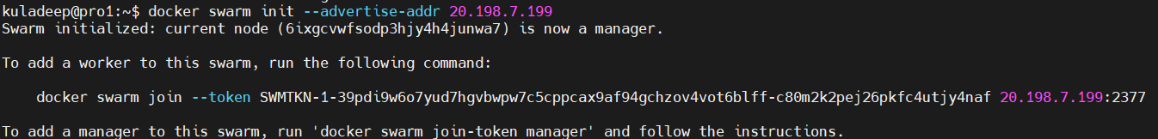

- Main Points of Docker Swarm (Key Features)
- Cluster Management : Combines multiple Docker nodes into one cluster, Nodes work together automatically
- Manager & Worker Nodes :
Manager: Controls cluster, scheduling, state
Worker: Runs containers
- Service-Based Model : You manage services, not individual containers, Swarm maintains desired state
- High Availability : Containers are restarted automatically on failure, Ensures services stay available
- Built-in Load Balancing : Distributes traffic across container replicas, Uses routing mesh
- Easy Scaling : Scale containers up/down instantly
docker service scale web=5
- Secure by Default : TLS encrypted communication, Automatic key & cert rotation
- Easy Setup : Simple commands, Minimal configuration compared to Kubernetes

- Docker Swarm is a native Docker orchestration tool used to deploy, scale, and manage containerized applications across multiple nodes with high availability and built-in load balancing.

- DOCKER VOLUMES
In Azure we are allocating ram to VM hence no of VM created depends on RAM
In a docker host, you can create multiple containers
Because ram is not allocating to containers, it is just limiting but RAM is allocated completely
If one container uses all RAM then for next containers can not run due to RAM unavailable
To avoid these issues we use Limit RAM usage
It is configuring limit of ram allocating for avoiding ram allocation issues

- For checking docker container CPU usage and limit
- Use command : docker stats
- docker → Docker CLI (no full form; named after shipping containers 🐳)
- stats → Statistics

- Displays real-time resource usage statistics of running Docker containers
- It shows live metrics such as : CPU usage, Memory usage, Memory limit, Network I/O, Block I/O, Number of processes (PIDs)

Field | Meaning
CPU % | CPU usage of container
MEM USAGE / LIMIT | Memory consumed vs allowed
NET I/O | Network traffic
BLOCK I/O | Disk read/write
PIDS | Processes inside container

- While creating and run container limiting ram usage
- Use command : docker run -dit --name sai --memory=”1g” ubuntu
- docker → Docker CLI (no full form; named after shipping containers 🐳)
- run → Create and start a new container
- -d → Detached mode (runs in background)
- -i → Interactive mode (keeps STDIN open)
- -t → Allocate a TTY (terminal)
- --name → Assign a name to the container
- sai → User-defined container name
- --memory → Set memory limit for the container
- 1g → 1 Gigabyte RAM
- ubuntu → Ubuntu Linux image
- Runs an Ubuntu container in detached interactive mode, names it sai, and limits its memory usage to 1 GB

- For creating container with RAM and CPU usage limit
- Use command : docker run -dit --name sai2 --cpu-shares 512 –memory=”1g” ubuntu
- docker → Docker CLI (no full form; named after shipping containers 🐳)
- run → Create and start a new container
- -d → Detached mode (runs in background)
- -i → Interactive mode (keeps STDIN open)
- -t → Allocate a TTY (terminal)
- --name → Assign a name to the container
- sai2 → User-defined container name
- --cpu-shares → CPU priority weighting
- 512 → Relative CPU share value (default = 1024)
- --memory → Set memory limit
- 1g → 1 Gigabyte RAM
- ubuntu → Ubuntu Linux image
- Runs an Ubuntu container named sai2 in detached interactive mode, limits its memory to 1 GB, and assigns it half the default CPU priority

By default when you create a container thin writable container will be formed
What ever operations we do it will be done in this layer
It will be sync to container Life cycle
When we delete container layer gets delete or destroyed hence,
Data will be lost
To avoid it we use volumes

- Volumes :
- A Docker volume is a persistent storage mechanism managed by Docker that stores data outside the container’s filesystem.
- Data in a volume survives container stop, delete, and recreate.

- Docker Volumes are Used for :
- Docker volumes are used to persist and manage container data safely and efficiently.

- Main Points of Docker Volumes :-
- Data Persistence : Container data is not lost when container is removed, Essential for databases
- Independent of Container Lifecycle : Volumes exist separately from containers, Can be reused by multiple containers
- Data Sharing : Multiple containers can access the same volume, Useful in multi-tier applications
- Better Performance : Faster than container filesystem, Optimized for heavy I/O workloads
- Easy Backup & Migration : Volumes can be backed up and restored, Suitable for production environments
- Docker-Managed Storage : Docker handles storage location and permissions, No need to manage host paths manually

- Docker volumes provide persistent, reusable storage for containers, independent of the container lifecycle.

- To store permanent data volumes are stored
- Volumes can be created on docker host
- When we create volume separate and create container to it data stored
when we delete container and create one more container
now when we attach this volume to this 2nd container volume gets attached and 1st container data is safe and won’t be deleted until volume gets deleted
- Single volume can attach to multiple container and can be used as a shared file or volume
- Volume can be attached using these commands : --mount, -v, --volume=-from
- We can mount present working directory as : $pwd

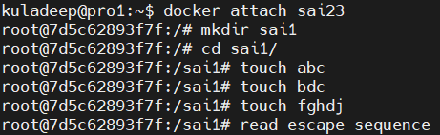

- Docker volume commands
- For listing out volumes : docker volume ls
- docker → Docker CLI (no full form; named after shipping containers 🐳)
- volume → Docker volume management command
- ls → LiSt
  - Lists all Docker volumes available on the Docker host
  - It shows : Volume names, Volume drivers (usually local)
  - Command is used : Check existing persistent storage, Identify unused volumes, Manage data outside container lifecycle

- For creating volume : docker volume create test
- docker → Docker CLI (no full form; named after shipping containers 🐳)
- volume → Docker volume management command
- create → Create a new resource
- test → User-defined volume name
  - Creates a Docker volume named test
  - What this means:
- A persistent storage area is created on the Docker host
- Data stored in this volume remains even if containers are deleted
- Volume can be reused by multiple containers

- For checking or inspect volume : docker volume inspect test
- For attaching volume to container : docker run -dit --name sai --mount source=test,destination=/data ubuntu

- For attaching volume to container 2nd method : docker run -dit --name sai3 -v test:/data ubuntu
- For attaching volume to container 3rd method : docker run -dit –volumes-from sai3 –name sai4

- For mapping pwd or path to container : docker run -dit --name sai5 -v “$(pwd)”:/data ubuntu
- To enter container : docker exec -it <container_name> /bin/bash

- Custom Images
- Docker is mainly used for images
- Docker is used for image creation using docker file

- Manual :
- Create container using ubuntu : docker run -dit --name <container_name> ubuntu
- To enter or login to container : docker exec -it <container_name> /bin/bash

Now ping command does not work as ping function is not installed
- Apt install update
- For install ping : sudo apt install -y iputils-ping
- For creating image using running container : docker commit <running_container_name> <new_image_name>

- Now create container using newly created image : docker run -dit --name <container_name> <new_image_name>

- For login or enter into new container : docker exec -it <container_name> /bin/bash
- For check image detailed : docker image inspect <image_name>
In layers when we install any function or software or app it will form as updates in layers

- For changing image details : docker commit --help
- For pausing container to create image -p is optional
- Default it will pause while creating

- IMAGE CREATION USING DOCKER FILE
- What is image creation :
- Image creation is the process of building a reusable template that contains :
  - Operating system or base environment, Application code
  - Required libraries and dependencies, Configuration files

- What is image creation in docker :
- Image creation in docker is the process of building a image in docker, which is a read-only template used to create containers.
- A Docker image contains : Application code, Libraries, Dependencies, Runtime environment

- Image creation using a Dockerfile means building a Docker image by following a set of instructions written in a file called Dockerfile.
- A Dockerfile is a blueprint for creating Docker images.

- What is docker file :
- A docker file is a simple file with instructions to build image
- Automation of docker image creation

Or

- A Dockerfile is a build configuration file that defines :
- Base image
- Application code
- Dependencies
- Environment variables
- Commands to run
- It is used by the docker build command to create an immutable image.

- Image Creation Works (Flow)
- Dockerfile → docker build → Docker Image → Container

- Docker File uses :
    - Application Portability : Runs same in Dev, Test, Production.
" Works on my machine " problem is solved.
    - Lightweight Virtualization : Uses OS-level virtualization (Linux kernel features like namespaces & cgroups).

    - Fast Deployment : Containers start in seconds (no full OS boot).

    - Dependency Management : All libraries + runtime packaged inside image.

    - Microservices Architecture : Each service runs in separate container.

- Use a Docker file :
- Instead of manually configuring containers every time, a Dockerfile allows you to:
  - Automate image creation, Ensure consistency across environments
  - Version-control your image build process

- Format of Dockerfile
Create folder and go to it
Create docker file named Dockerfile

Step 1 : create a docker file named Dockerfile
Step 2 : add instructions
Step 3 : build docker file to create image
For random name : docker build
For naming : docker build -t imagename:version directoryofdockerfile

Step 4 : run image to create container
docker run image

- To create a docker file
- Ex 1 : Flask

mkdir flask-app
cd flask-app

Step 2: Create file named app.py

from flask import Flask
app = Flask(__name__)
@app.route("/")
def home():
return "Hello from Docker Flask App!"
if __name__ == "__main__":
app.run(host="0.0.0.0", port=5000)

Step 3: Create requirements.txt
Flask

Step 4: Create Dockerfile
# Base OS
FROM ubuntu:latest
# Avoid interactive prompts
ENV DEBIAN_FRONTEND=noninteractive
# Update packages and install python & pip
RUN apt update && \
apt install -y python3 python3-pip
# Set working directory
WORKDIR /app
# Copy files into container
COPY . /app
# Install python dependencies
RUN pip3 install -r requirements.txt
# Expose port
EXPOSE 5000
# Run application
CMD ["python3", "app.py"]

Run : docker build -t flask-ubuntu-app .

- Ex 2 : nmap
# Base OS
FROM ubuntu:latest

# Avoid interactive prompts
ENV DEBIAN_FRONTEND=noninteractive

# Update packages and install nmap
RUN apt update && \
apt install -y nmap && \
apt clean

# Default command
CMD ["nmap", "--version"]

- Frequently Used Dockerfile Keywords (Must-Know)
Keyword | Full Form | Use / Meaning
FROM | Base Image | Defines the base image for your Docker image
RUN | Run Command | Executes commands during image build (install packages, updates)
CMD | Command | Default command executed when container starts
ENTRYPOINT | Entry Point | Main executable for the container
COPY | Copy Files | Copies files from host to container
ADD | Add Files | Like COPY, but also supports URL & auto-extract
WORKDIR | Working Directory | Sets working directory inside container
EXPOSE | Expose Port | Documents container listening port
ENV | Environment Variable | Sets environment variables
ARG | Argument | Build-time variables

Normal / Regularly Used Dockerfile Keywords
Keyword | Full Form | Use / Meaning
LABEL | Metadata Label | Adds metadata like maintainer, version
USER | User Switch | Sets user for running container
VOLUME | Volume Mount | Creates mount point for persistent data
ONBUILD | On Build Trigger | Executes instruction when used as base image
SHELL | Shell Instruction | Changes default shell (/bin/sh, PowerShell)
HEALTHCHECK | Health Check | Checks container health status
STOPSIGNAL | Stop Signal | Defines signal for stopping container
MAINTAINER | Maintainer Info | Defines image author (deprecated)

Rarely Used / Advanced Dockerfile Keywords
Keyword | Full Form | Use / Meaning
ADD | Add Resources | Used rarely due to unpredictable behavior
ONBUILD | On Build Hook | Mostly used in base images
SHELL | Shell Configuration | Used mainly for Windows containers
STOPSIGNAL | Stop Signal | Advanced graceful shutdown handling
HEALTHCHECK | Health Monitor | Used in production-grade containers

Special Dockerfile Syntax Keywords (Advanced)
Keyword | Full Form | Use
AS | Alias Name | Used in multi-stage builds
# syntax= | BuildKit Syntax | Enables advanced Docker build features

- A–Z Dockerfile Keywords Summary
A → ADD, ARG, AS
C → CMD, COPY
E → ENTRYPOINT, ENV, EXPOSE
F → FROM
H → HEALTHCHECK
L → LABEL
M → MAINTAINER
O → ONBUILD
R → RUN
S → SHELL, STOPSIGNAL
U → USER
V → VOLUME
W → WORKDIR

Keyword | Full Form | Meaning | Use
ADD | — | Advanced Copy | Copies files, supports URL download & auto-extract tar
ARG | Argument | Build-time Variable | Defines variables used during image build
CMD | Command | Default Execution Command | Runs default command when container starts
COPY | — | Copy Files | Copies files from host to container
ENTRYPOINT | Entry Point | Main Executable | Defines main fixed command of container
ENV | Environment Variable | Runtime Variable | Sets environment variables inside container
EXPOSE | — | Expose Port | Documents which port container listens on
FROM | — | Base Image | Specifies base image (must be first instruction)
HEALTHCHECK | — | Health Monitor | Checks container health status
LABEL | — | Metadata Tag | Adds metadata like author, version
MAINTAINER (Deprecated) | Maintainer | Image Author | Defines author info (replaced by LABEL)
ONBUILD | On Build Trigger | Trigger Instruction | Executes instruction when image is used as base
RUN | — | Run Command | Executes command during build process
SHELL | — | Default Shell | Overrides default shell (like /bin/sh)
STOPSIGNAL | Stop Signal | Stop Signal Definition | Defines signal to stop container gracefully
USER | — | User Context | Sets user to run container
VOLUME | — | Persistent Storage | Creates mount point for external storage
WORKDIR | Working Directory | Set Default Directory | Sets working directory inside container

- Most important: FROM, RUN, COPY, CMD, ENTRYPOINT

- Difference between ENTRYPOINT + CMD

Feature | ENTRYPOINT | CMD
Purpose | Main application | Default arguments / command
Full form | Entry Point | Command
Overrides | ❌ Hard to override | ✅ Easy to override
Behavior | Always executed | Can be replaced
Usage | Container behaves like executable | Provides defaults

- ENTRYPOINT → What this container IS
- CMD → How it runs by default
- ENTRYPOINT = Fixed
- CMD = Flexible

- When to use what
Scenario | Use
Fixed app container (nginx, java app) | ENTRYPOINT
Change command at runtime | CMD
Both together (best practice) | ENTRYPOINT + CMD

ENTRYPOINT defines the main process of the container and cannot be easily overridden, while
CMD provides default arguments that can be overridden at runtime.

- Difference between ADD vs COPY

Feature | COPY | ADD
Full form | Copy Files | Add Files
Function | Simple file copy | Advanced file handling
URL support | ❌ No | ✅ Yes
Auto extract or Extracts .tar | ❌ No | ✅ Yes (tar)
Predictability | ✅ High | ❌ Low
Recommendation | ✅ Preferred | ❌ Avoid unless needed
Copies local files | ✅ | ✅
Transparent behavior | ✅ Yes | ❌ No

Copy : Copy files from Docker Host to Image
Add : Copy files from docker host to image and extract it only local zip files

- Syntax
COPY : COPY app.py /app/
ADD : ADD app.tar.gz /app/

- Why Docker recommends COPY over ADD?
ADD does too many things
Hard to debug
Breaks image caching
Less secure

👉 Use ADD only when:
You need auto-extract
You need to download from URL

ARG is build-time, ENV is run-time

- IMAGE OPTIMIZATION
- Image optimization
- In docker it is to reducing the size, build time, and attack surface of a Docker image while keeping it fully functional.
- Goal: smaller, faster, safer images.

- Image Optimization is Used for :- Build faster, Pull faster, Deploy faster, Consume less storage, Improve security, Reduce costs (CI/CD, cloud)

- Main Points of Docker Image Optimization
    - Reduce Image Size : Smaller images download quickly, Less disk usage.
Example : FROM alpine
instead of : FROM ubuntu
    - Faster Builds & Deployments : Fewer layers = faster builds, Less network transfer
    - Improved Security : Fewer packages = fewer vulnerabilities, Smaller attack surface
    - Efficient Layer Caching : Optimized Dockerfile order improves cache reuse, Speeds up CI/CD pipelines
    - Better Performance : Lower startup time, Faster container scaling

- Common Image Optimization Techniques :-
- Use Small Base Images : FROM alpine
- Multi-Stage Builds : Removes build tools from final image.
FROM node AS build
RUN npm install

FROM node:alpine
COPY --from=build /app /app
- Combine RUN Commands :
RUN apt update && apt install -y nginx && rm -rf /var/lib/apt/lists/*
- Remove Unnecessary Files : Clear cache, Delete temp files
- Use .dockerignore : Exclude unnecessary files.

- Docker image optimization is the practice of minimizing image size and complexity to improve performance, security, and deployment efficiency.

- Docker file main code for optimize
apt install -y --no-install-recommends
rm -rf /var/lib/apt/lists/*

- Docker file before optimize
# Base OS
FROM ubuntu:latest
# Avoid interactive prompts
ENV DEBIAN_FRONTEND=noninteractive
# Update packages and install nmap
RUN apt update && \
apt install -y nmap && \
apt clean
# Default command
CMD ["nmap", "--version"]

- After optimize

FROM ubuntu:22.04
ENV DEBIAN_FRONTEND=noninteractive
RUN apt update && \
apt install -y --no-install-recommends nmap && \
rm -rf /var/lib/apt/lists/*
CMD ["nmap", "--version"]

Before optimize map
After optimize nmap1

- For least size
- We can use alphine as smallest of all

FROM alpine:latest
RUN apk add --no-cache nmap

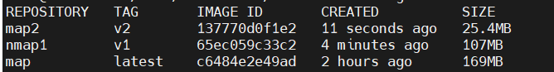

Using normal ubuntu : map
Using normal ubuntu and compose or reduce size : nmap1
Using alphine lease size : map2

- Use command vi dockerfile
- Inside docker file
  - FROM busybox
  - WORKDIR /tmp/
  - ADD tomcat link .
  - CMD [“sh”]
- Use command : docker build -t copyadd:v1 .

while creating image
it will create a temporary container which is duplicate,
install application and requirements in that with required dependencies and
convert to image and at last container gets destroyed or deleted

CMD : for over riding parameters which are already present
entry point : can not over ride parameters

Onbuild : later use ( triggering the command later )
So when we write commands in container and convert it to image
Image becomes parent image
Using this parent image when we want to create a container the commands saved in image will execute in new container

The onbuild instruction adds triggers to images.
A trigger is executed when the image is used on the basis of another image
A docker build executes ONBUILD commands before any commands before any command in a child docker file

Docker file :
FROM nginx
WORKDIR /usr/share/nginx/html
ONBUILD COPY index.html .

- Multi stage Docker file :

To Optimize docker image :
Dependencies segregate
Multi stage file
Nginx : alpine, slim, distroless

WinSCP : it is software to move files from local PC to VM

Use command : mv Dockerfile Dockerfile.old
Mv dockerfile.new dockerfile

Check it again for practice

- MULTI STAGE DOCKER FILE

- Multi-Stage Docker file
- A multi-stage Dockerfile uses multiple FROM statements in one Dockerfile.
- Build the app in one image, run it in another smaller image
- Only the final required files are kept.
- Build tools are left behind.

- This feature was introduced in Docker 17.05 in:
- It allows separating : Build stage, Runtime stage

- Use of Multi – Stage Docker file
- Reduce Image Size : Only required files are copied.
- Improve Security : Build tools not present in final image.
- Clean Production Image : Better for deployment.
- Faster Pull & Push

- Use Multi-Stage Dockerfile :
    - Smaller image size : Removes compilers, build tools, Faster downloads & deployments
    - Better security : No build tools in final image, Smaller attack surface
    - Cleaner images : Only app + runtime, No unnecessary files
    - Better performance : Lightweight containers start faster
    - Best practice : Used in production, Common in CI/CD pipelines

- Main points
- Uses multiple FROM statements
- Separate build stage and run stage
- Final image contains only required files
- Reduces image size
- Improves security and efficiency

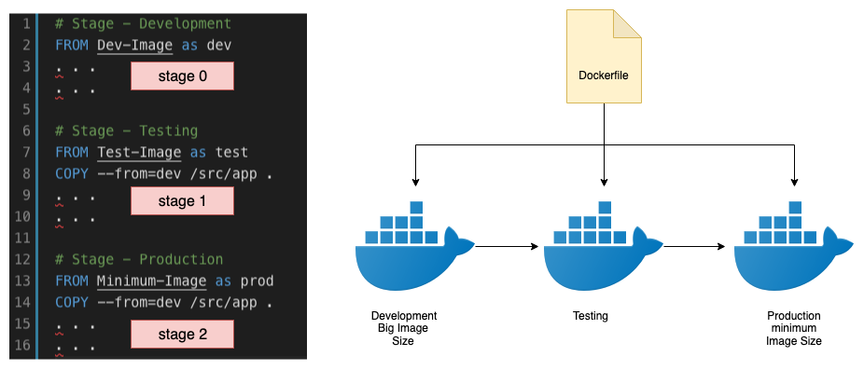

- A multi-stage Dockerfile builds an application in one stage and runs it in another to create a smaller, secure image.

TO OPTIMIZE your image we use multi stage docker file

Ex : using nginx and nmap

# -------- Stage 1: Builder --------
FROM ubuntu:22.04 AS builder

ENV DEBIAN_FRONTEND=noninteractive

RUN apt update && \
apt install -y --no-install-recommends nmap nginx && \
rm -rf /var/lib/apt/lists/*

# -------- Stage 2: Final Image --------
FROM ubuntu:22.04

# Copy only required binaries from builder
COPY --from=builder /usr/bin/nmap /usr/bin/nmap
COPY --from=builder /usr/sbin/nginx /usr/sbin/nginx
COPY --from=builder /etc/nginx /etc/nginx
COPY --from=builder /var/www/html /var/www/html

EXPOSE 80

CMD ["nginx", "-g", "daemon off;"]

Normal Dockerfile = Build + Run everything in one image
Multi-Stage Dockerfile = Build in one stage, Copy required files, Run in clean image

- Normal Dockerfile Example
FROM ubuntu:22.04
RUN apt update && apt install -y nmap nginx
CMD ["nginx", "-g", "daemon off;"]

Problem :
Build tools remain in final image
Larger size
More vulnerabilities

- Multi-Stage Dockerfile Example
# Stage 1 - Builder
FROM ubuntu:22.04 AS builder
RUN apt update && apt install -y nmap nginx
# Stage 2 - Final
FROM ubuntu:22.04
COPY --from=builder /usr/bin/nmap /usr/bin/nmap
COPY --from=builder /usr/sbin/nginx /usr/sbin/nginx
COPY --from=builder /etc/nginx /etc/nginx
CMD ["nginx", "-g", "daemon off;"]
Here:
Stage 1 installs everything
Stage 2 copies only required files
Final image is smaller

- Difference bw Docker file and Multi Docker File
Feature | Normal Dockerfile | Multi-Stage Dockerfile
FROM statements | One | Multiple
Image size | Large | Smaller
Build tools remain? | Yes | No
Security | Lower | Higher
Production ready | Not ideal | Best practice
Complexity | Simple | Moderate

Simple example
# Stage 1 – build
FROM node:18 AS build
WORKDIR /app
COPY . .
RUN npm install && npm run build

# Stage 2 – run
FROM nginx:alpine
COPY --from=build /app/dist /usr/share/nginx/html

Example 2 :
FROM open
WORKDIR /app
COPY ..
RUN apk update && apk add maven
RUN mvn package
FROM openjdk:17-alphine
WORKDIR /app
COPY –from=build /app/target/*.jar app.jar
EXPOSE 8080
CMD [“”java”, “jar”, “ap.jar”]

Interview :
“ Multi-Stage Dockerfile uses multiple FROM instructions to separate build and runtime environments.
It helps reduce final image size and improves security compared to a normal single-stage Dockerfile.”

- DOCKER COMPOSE

- Docker Compose
- It is a tool used to run multiple containers together using one file.

- Docker Compose is a tool used to define and run multi-container Docker applications using a single YAML file.
  - Instead of running multiple docker run commands,
  - We define everything inside a docker-compose.yml file,
  - Then start all containers with one command.

- One file → many containers → one command

- Use Docker Compose?
- Run multi-container apps easily
Example : Web app, Database, Cache
- All started together

- One configuration file : Uses docker-compose.yml, All settings in one place

- One command to start/stop :
docker compose up
docker compose down
- No need to run many docker run commands.

Automatic networking : Containers can talk using service names, No need to create networks manually

- Good for development & testing : Easy to use, Fast setup, Same environment for everyone

- Run Multiple Containers Easily
Example : Nginx, App server, Database
- Instead of running 3 commands manually,
- Compose runs everything in one shot.

- Manage Microservices
- Perfect for : Web + API + DB
- Testing environments
- Dev environments

- Automatic Network Creation : Containers can talk to each other using service names.

- Version Control : You can store docker-compose.yml in Git.

- Simple example
services:
web:
image: nginx
ports:
- "8080:80"

db:
image: mysql
Run:
docker compose up

- Main points (exam-ready)
- Manages multiple containers
- Uses YAML file
- Single command to run everything
- Built-in networking
- Saves time and effort

- Docker Compose is used to define and run multi-container applications using a single configuration file.

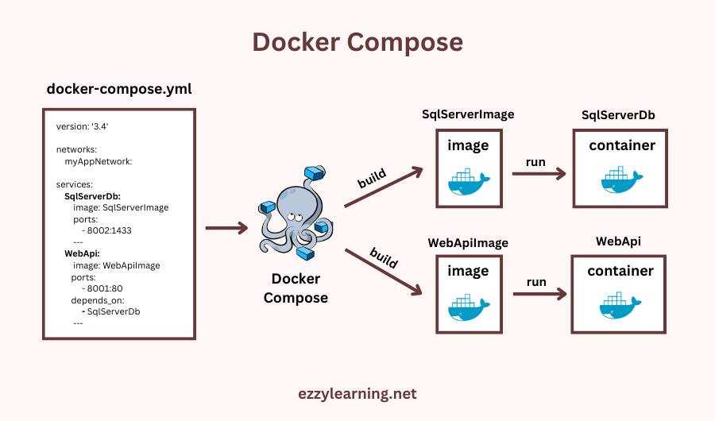

Default bridge network : communicate via private ip
Custom bridge network : communicate via dns, host name also private ip

3TR architecture
Mango db is a database to store data
Mango express is a application to login to mango db and retrieve data

Dbusername
Db password
Env : -e4-e volume mount
If we do not provide -e after creating volumes we need to add all
To avoid this now we are adding

Username and password
-e dbuser, pwd, url

Commands :
docker network create Sai
network ls
docker volume create volumesai
docker volume ls

All containers are in one network hence all will be communicated

1 Sir command :
Docker run -dit -p 27017:27017 -e MONGO_INITDB_ROOT_USERNAME=admin -e MONGO_INITDB_ROOT_PASSWORD=password -e PWD=/ -v mongodb-data:/data/db –name mern_library_nginx_mongodb_1 –net library-mern-api mongo

My command :
docker run -dit \
-p 27017:27017 \
--network Sai \
--name mern_library_mongodb_1 \
-e MONGO_INITDB_ROOT_USERNAME=admin \
-e MONGO_INITDB_ROOT_PASSWORD=password \
-v volumesai:/data/db \
mongo

port = -p 27017:27017
environment variable = -e
username = MONGO_INITDB_ROOT_USERNAME=admin
password = MONGO_INITDB_ROOT_PASSWORD=password
volume and present working path : PWD=/ -v volumesai:/data/db
for naming container = --name
/ for mounting container inside
Network attaching = --net Sai

For accessing database
Mongo db = mongo express
Mysql = mysql work bench
Mssql = ssms sequel

Sir 2nd command :
docker run -dit -p 8081:8081 -e ME_CONFIG_MONGODB_ADMINUSERNAME=admin -e ME_CONFIG_MONGODB_ADMINPASSWORD=password --net library-mern-api --name mern_library_nginx_mongo-express_1 -e ME_CONFIG_MONGO_SERVER=mern_library_nginx_mongodb_1 -e ME_CONFIG_BASICAUTH_USERNAME=admin -e ME_CONFIG_BASICAUTH_PASSWORD=admin12345 mongo-express

my 2nd command
docker run -dit \
-p 8081:8081 \
--network Sai \
--name mern_mongo-express_1 \
-e ME_CONFIG_MONGODB_ADMINUSERNAME=admin \
-e ME_CONFIG_MONGODB_ADMINPASSWORD=password \
-e ME_CONFIG_MONGODB_SERVER=mern_library_mongodb_1 \
-e ME_CONFIG_BASICAUTH_USERNAME=admin \
-e ME_CONFIG_BASICAUTH_PASSWORD=admin12345 \
mongo-express

for checking connection :
docker exec -it mern_mongo-express_1 ping mern_library_mongodb_1

